Levels of Classification
Living organisms are classified into progressively smaller and smaller groups.
K

P

C

O

F

G

S

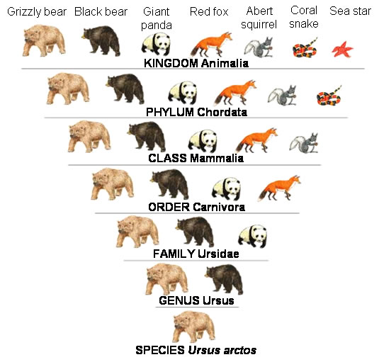
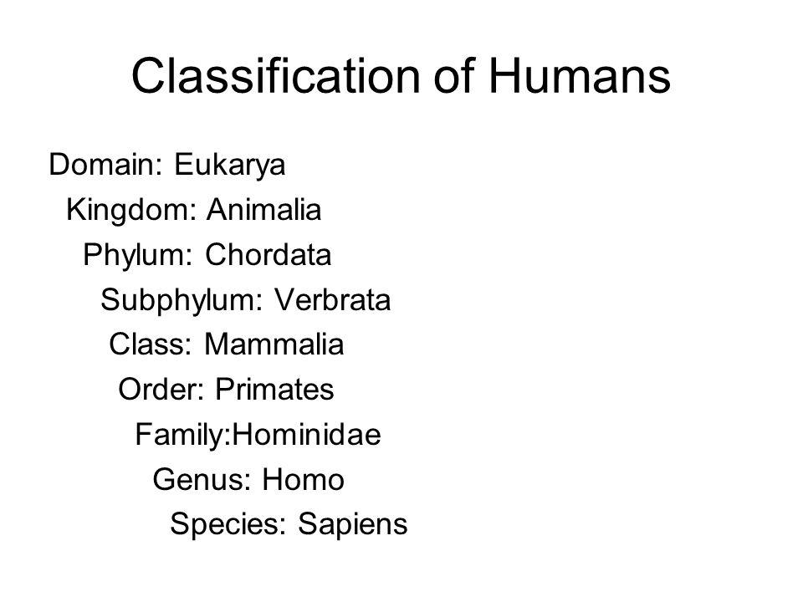

Questions.
- Which will have more species in it, order of genus?

- Members of the same species are able to reproduce and produce fertile offspring. This means that they can mate and produce babies. These babies can in turn grow up to produce their own offspring.

- A dingo can mate with a domestic dog to produce puppies. Those puppies can then grow up and produce their own puppies. Are the dingo and the domestic dog the same species? Give a reason for your answer.
- The horse and the donkey can mate to produce an animal called a mule. When a mule grows up it cannot reproduce. A mule is not fertile. Are horses and donkeys the same species? Give a reason for your answer.

